
Using Gemini for Vibe Coding Task.

Screenshot 1:
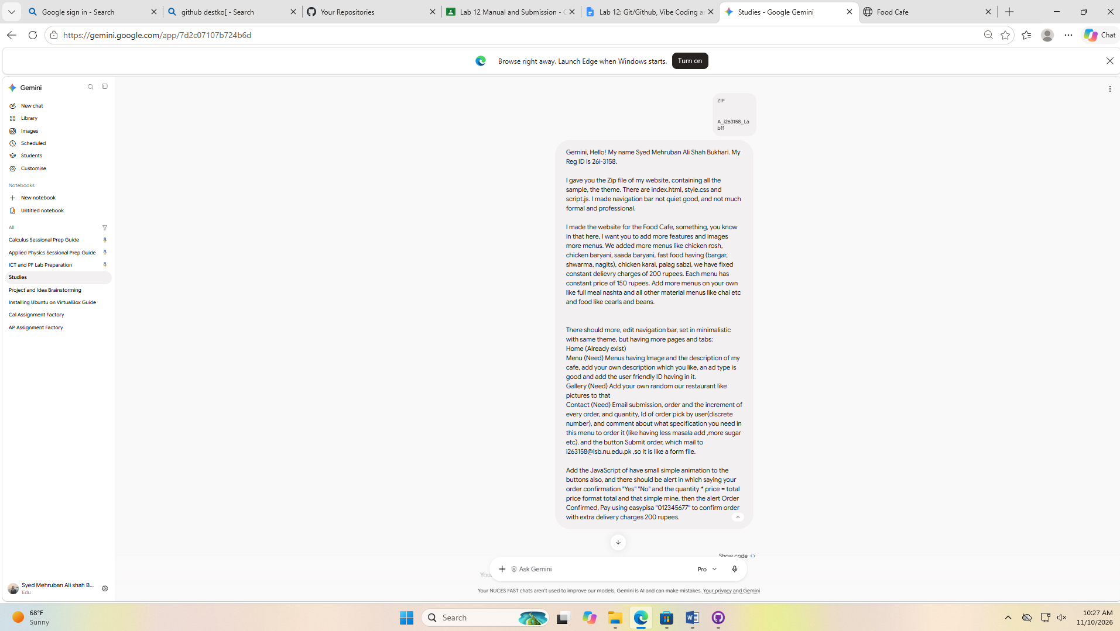
## Prompt 1:
Gemini, Hello! My name Syed Mehruban Ali Shah Bukhari. My Reg ID is 26i-3158.

I gave you the Zip file of my website, containing all the sample, the theme. There are index.html, style.css and script.js. I made navigation bar not quiet good, and not much formal and professional.

I made the website for the Food Cafe, something, you know in that here, I want you to add more features and images more menus. We added more menus like chicken rosh, chicken baryani, saada baryani, fast food having (bargar, shwarma, nagits), chicken karai, palag sabzi, we have fixed constant delievry charges of 200 rupees. Each menu has constant price of 150 rupees. Add more menus on your own like full meal nashta and all other material menus like chai etc and food like cearls and beans.

There should more, edit navigation bar, set in minimalistic with same theme, but having more pages and tabs:
Home (Already exist)
Menu (Need) Menus having Image and the description of my cafe, add your own description which you like, an ad type is good and add the user friendly ID having in it.
Gallery (Need) Add your own random our restaurant like pictures to that
Contact (Need) Email submission, order and the increment of every order, and quantity, Id of order pick by user(discrete number), and comment about what specification you need in this menu to order it (like having less masala add ,more sugar etc). and the button Submit order, which mail to i263158@isb.nu.edu.pk ,so it is like a form file.

Add the JavaScript of have small simple animation to the buttons also, and there should be alert in which saying your order confirmation "Yes" "No" and the quantity * price = total price format total and that simple mine, then the alert Order Confirmed, Pay using easypisa "012345677" to confirm order with extra delivery charges 200 rupees.

Result:
The Sadda barayni was not rendering.
Screenshot 2:
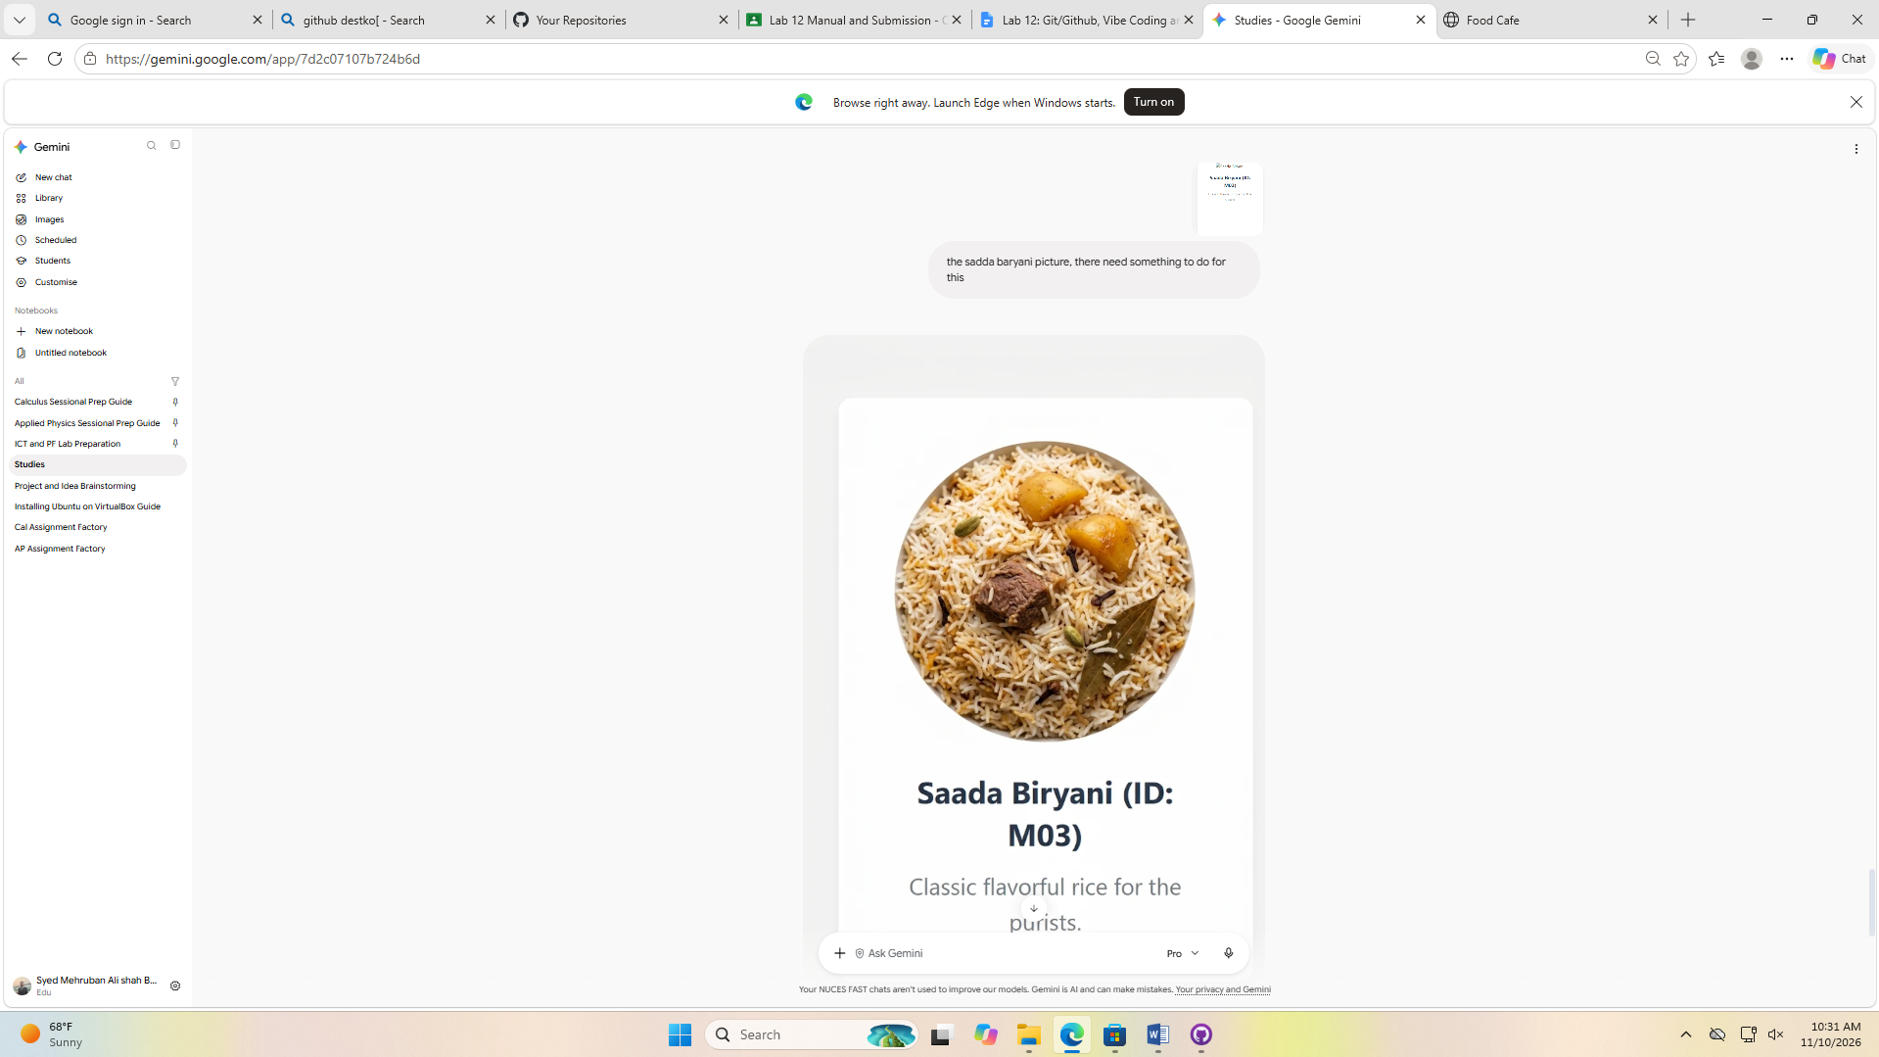
## Prompt 2:
Attachment Screenshot of problem. And Prompt:
the sadda baryani picture, there need something to do for this
Result:
Not quiet he only generated the image, I think I had the problem with the prompt, I usually accidently press enter.
He gave the zip file. I result was quiet amazing but there were no multiple html files, there was made ID Hyperlink to surf through the only index.html page, only scroll down or scroll up automatically. So I used the second prompt for the generation of each tabs as separate entity.
Screenshot 3:
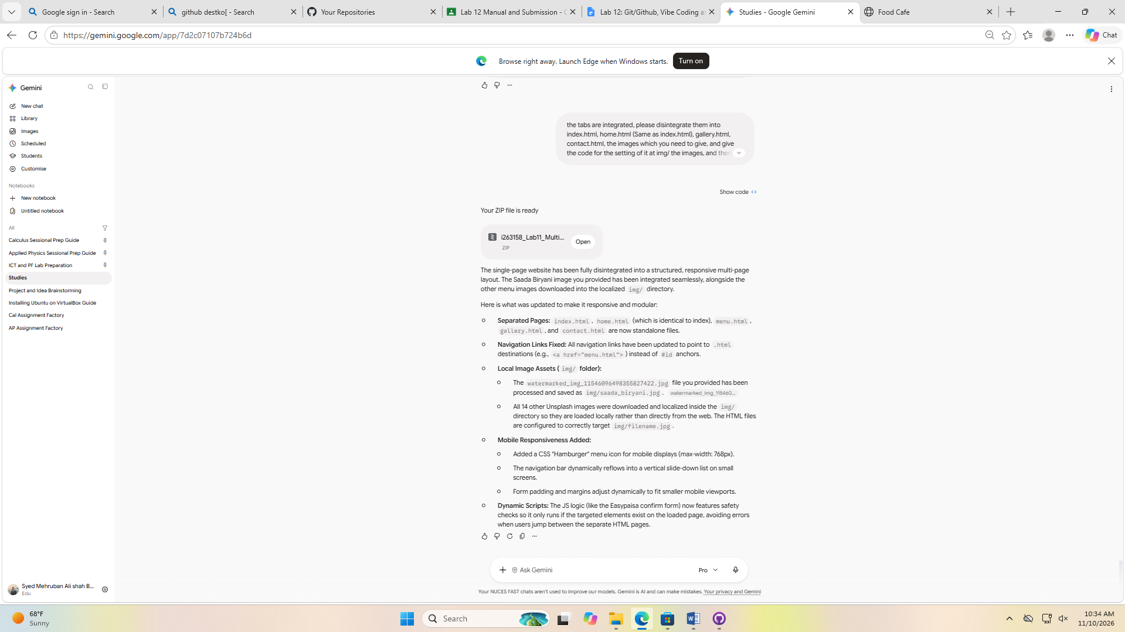
## Prompt 3:
the tabs are integrated, please disintegrate them into index.html, home.html (Same as index.html), gallery.html, contact.html, the images which you need to give, and give the code for the setting of it at img/ the images, and there script.js and style.css etc

Morever i need you to make this site more responsive and don

Result:
Just the way I expected he made it, but the images he did’nt uploaded, so I set them manually.

